SF Quick Access
Chrome extension for Salesforce developers and admins
Installation & User Guide · Version 1.1.0 · October 2026

1. Overview
SF Quick Access puts the Salesforce tasks you do most one click away, inside your browser: browsing metadata, reading debug logs, deploying a class, changing record owners, and inspecting every field on a record. It uses the session you are already logged into, so it works with any production, sandbox or scratch org without a separate sign-in.
There are two ways in:
- The main window — click the extension icon while you are on a Salesforce tab. A sidebar on the left lists the tools; the one you pick opens on the right.
- The page tabs — on Salesforce pages, small tabs on the right edge open the Record Inspector (on record pages) and Data export (on any page) in a new browser tab, and a Fill form tab appears whenever a form is on screen. See sections 5, 7.4 and 7.5.
Where your data goes. Nothing is sent to a third-party server. The extension calls Salesforce’s own REST, Tooling and Metadata APIs with your session. It stores only your preferences, pins and the progress of a running job, in your own browser.

2. The tools at a glance
Everything in the extension in one table. Each tool is covered in its own section below.
Tool | Where to find it | What it does
Data export | Data export tab, on any Salesforce page | Builds and runs a SOQL query with field suggestions (including parent fields such as Account.Name), then downloads the results as CSV. Section 7.4.
Fill form | Fill form tab, when a form is on screen | Fills a long form (or a screen flow) with realistic test data: every empty field, or only the required ones. Section 7.5.
Record Inspector | Inspect tab on record pages | Shows every field on a record, lets you edit values, follow lookups, see field history and usage. Section 5.
Search everything | Sidebar, or Ctrl+K | One search across objects, flows, profiles, permission sets, users, Apex classes and fields. Section 4.
Configurations, Users and Pinned | Sidebar | Browse the org’s metadata and users, pin favourites, log in as a user, start a debug log. Section 6.
Find references, Delete by ID, Change owner | Record analysis & cleanup | Find what points at a record, delete a record, or move one user’s Leads, Accounts, Contacts or Opportunities to another, with a backup file first. Section 7.
Clear debug logs, Log Analyzer | Logs | Bulk-delete debug logs, or read one with a full breakdown, a user filter and a Debug-only view. Section 8.
Grant access | Sidebar | Grants Apex, Visualforce, field and object access to many profiles at once. Section 9.
Compare access | Sidebar, opens its own tab | Shows how two profiles or permission sets differ, with a plain-language answer first, then a matrix, and fields one object at a time. Read-only. Section 7.6.
Recent changes | Sidebar, directly below Quick Deploy | Lists the components changed lately, newest first, with who changed them. Filter by person, type and date, sort by person, and add what you need to Quick Deploy. Read-only. Section 9.3.
Quick Deploy | Sidebar | Deploys a few Apex classes, triggers, LWC, Aura, Visualforce, custom fields and labels from this org to another org you are logged into. Section 9.
Clear cache | Sidebar | Makes a Salesforce tab reload like a hard refresh every time, without a manual Ctrl+Shift+R. Section 10.
JSON beautifier, String converter | Text & JSON tools | Format and validate JSON, or reshape a list of items, for example into a SQL IN clause. Section 10.
Separate windows | Footer of the sidebar | Opens the tool in its own window or tab so it stays open while you work. One window per org. Section 4.
Light and dark themes | Footer of the sidebar | Switch themes at any time. Panels are colour-coded by what they do. Section 4.

3. Installation

Install the extension
- Unzip the package. You will see a folder named SF Quick Access (the extension) and two folders, tests and tools, that are only for maintainers.
- In Chrome, open chrome://extensions, switch on Developer mode, click Load unpacked, and choose the SF Quick Access folder (the one that contains manifest.json).
- Pin the extension from Chrome’s puzzle-piece menu so its icon is always visible.
- Open any Salesforce tab and refresh it once, so the extension can detect your session and add the Inspect tab to record pages.
- Click the extension icon. The main window opens.

Update to a new version
Replace the contents of the SF Quick Access folder with the new version, then click the reload arrow on the extension’s card in chrome://extensions. Chrome may ask you to approve new permissions. Refresh any open Salesforce tabs afterwards.

Permissions, and why each is needed
Permission | Used for
cookies | Reads your Salesforce session ID to make authenticated API calls, and to find the other orgs you are logged into for Quick Deploy.
tabs, activeTab | Finds the Salesforce tab you are on, and opens new tabs next to it.
storage | Remembers pins, theme and Clear Cache settings, and holds the progress of a running job.
clipboardRead, clipboardWrite | The Paste and Copy buttons.
browsingData | Clear Cache: clears cached data for your org’s domains only. Cookies are never cleared.
declarativeNetRequestWithHostAccess | Clear Cache: asks Salesforce for fresh copies on tabs where you switched it on. Limited to Salesforce domains.
Salesforce host access | *.salesforce.com, *.force.com, *.lightning.force.com, *.my.salesforce.com, *.my.salesforce-setup.com, *.cloudforce.com, *.visualforce.com. All API calls and the Inspect tab run only here.
Security note. The extension reads your Salesforce session cookie to act on your behalf. If your organisation restricts browser extensions, check with IT or Security before installing it widely.

4. Finding your way around

The main window
The sidebar on the left is the map; the panel on the right is where you work. Light and dark themes are shown below.
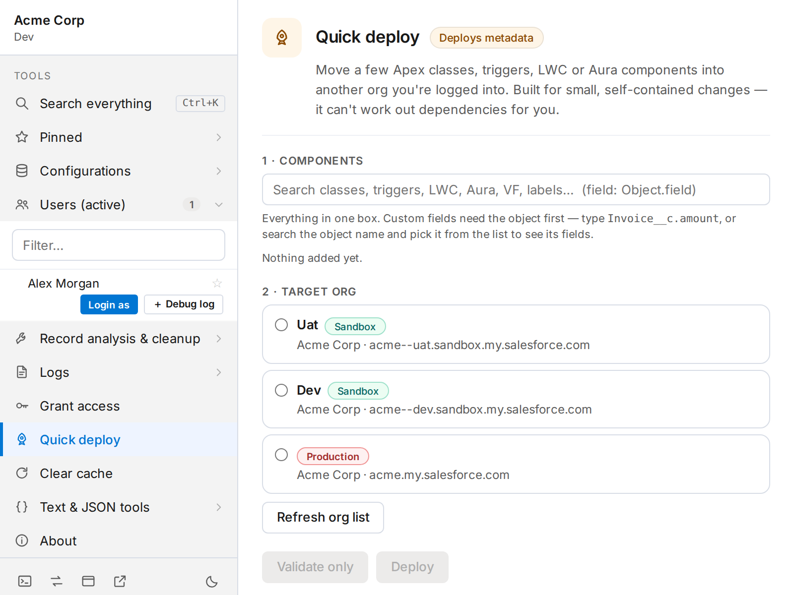
The main window in light theme, with Quick Deploy open
- Org block (top left). Shows the company on the first line and the environment under it, for example Acme Corp over Dev. Production is shown in red so you cannot mistake it. Hover to see the full host name. The environment is read from the org itself, not guessed from the web address.
- Tools. Every tool is a row. Rows with a chevron on the right expand to show what is inside; click again to collapse.
- Footer icons. Five small buttons along the bottom of the sidebar (below).
Footer icon | What it does
Developer Console | Opens the Developer Console for the current org in a new tab.
Switch to Salesforce Classic | Opens the current org in Salesforce Classic, in a new tab.
Open in a separate window | Pops the tool out into its own window that stays open while you work (see “Keep it open” below).
Open in a new tab | Opens the tool as a normal browser tab.
Theme (moon or sun) | Switches between light and dark. Your choice is remembered.

Search everything (Ctrl+K)
The first row of the sidebar, or Ctrl+K (Cmd+K on a Mac), opens one search box across Objects, Flows, Profiles, Permission sets, Users, Apex classes and Fields. Type, then pick a result to jump straight to it. Each group shows up to six matches.
Fields are searched live, only after you type three characters, and show up to 25 results. That search relies on a Salesforce object that some orgs do not expose; if your org does not, the Fields group simply stays empty. The Record Inspector is the reliable way to find a field on a specific record.

Colour-coded panels
Every panel has a coloured icon and a small tag in its header that tells you, before you click anything, what the tool does to your org.
Colour | Tag | Tools
Blue | Read-only | Find references. It only reads. (The Log Analyzer is also blue but carries no tag, because it can both read logs and delete one.)
Amber | Modifies records, permissions, or deploys metadata | Change owner, Grant access, Quick deploy.
Red | Deletes records, or deletes logs | Delete by ID, Clear debug logs. The destructive button is the only solid red in the product.
Grey | Browser only, or local only | Clear cache, JSON beautifier, String converter. These never change anything in Salesforce.

Keep it open: separate windows
The main window closes when you click away. To keep a tool open while you work in Salesforce, use Open in a separate window (or Open in a new tab) in the sidebar footer.
- One window per org. Each separate window is pinned to the org you opened it from. If you are logged into two orgs, open one window for each; they stay independent and never act on each other’s tabs.
- Opening a window for an org that already has one focuses the existing window rather than making a duplicate.
- The window title shows the org’s host name, so you can tell windows apart in the taskbar. If you close every tab for that org, the window says so by name rather than silently switching to another org.

New tabs open next to your current tab
Anything the extension opens for you — Developer Console, Classic, Login as, a record link — opens immediately to the right of your current tab, not at the end of the tab strip.

5. Record Inspector
The Record Inspector shows every field on a record in one table: API name, label, type and current value, plus who created and last changed it. From the same table you can edit values, follow lookups to related records, see a field’s change history, find what uses a field, and jump to its setup page.

5.1 Opening it
On any Salesforce record page, look for a small Inspect tab on the right edge of the screen. Click it and the record opens in a new browser tab, right beside the record. The tab follows you as you navigate, and it appears only on record pages, so you will not see it on the home page, list views or Setup.
Directly below it you will also see a Data export tab. That one is not about this record: it opens the query tool (section 7.4) and appears on every Salesforce page.
Just installed or updated? Refresh the Salesforce tab once. The page tabs are added when the page loads.

5.2 Reading the page
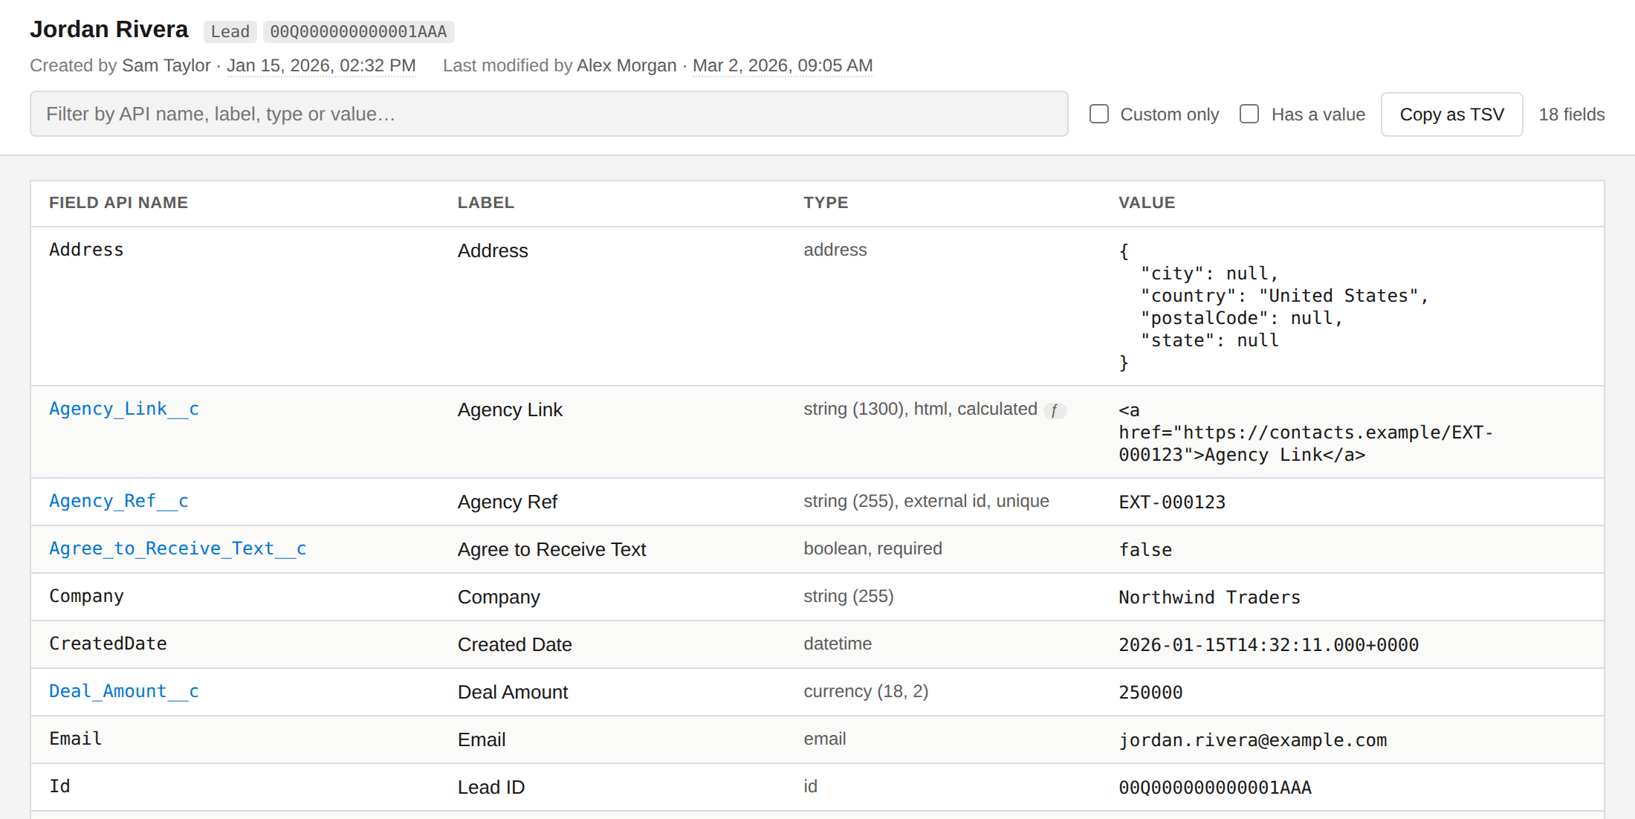
The Record Inspector: record header, audit line, filters and the field table
- Header. The record’s name, with the object’s API name and the record ID beside it.
- Audit line. Who created the record and who last modified it, with times in your local time zone. Hover a time to see the exact timestamp as Salesforce stores it.
- Table. One row per field, sorted by API name. Custom fields are shown in blue.

The Type column
The type is written the way Setup describes it, for example string (255), external id, unique, reference → User, currency (18, 2) or boolean, required. Two small badges add more:
- ƒ badge — a formula field. Hover the type to read the formula.
- Number badge on a picklist — how many active values it has. Hover the type to list them.

The Value column
You see | It means
(Blank), in italics | The field is readable but empty.
No access in red | The field exists but your field-level security hides it. This is deliberately different from blank.
A name, with an ID underneath | A lookup. The name is a link that opens the related record in Salesforce; the ID beneath it can be selected and copied. Record Type works the same way, so you get both the name and the ID.
A block of braces | A compound field such as an address, shown with all its parts.
0 or false | A real value. Zero and false are not treated as blank.

5.3 Finding things
- Filter box. Searches API name, label, type, value and formula text. Typing a field’s API name finds every formula that references it.
- Custom only hides standard fields. Has a value hides empty ones.
- Sort by clicking any column heading; click again to reverse.
- Field count at the right shows how many rows match (for example, 18 of 793).
- Copy as TSV copies the rows currently shown, tab-separated, ready to paste into Excel or Google Sheets. Filter first to copy only what you need.
- Keyboard: Ctrl+F (Cmd+F) jumps to the filter box. Esc closes an open menu or panel, or clears the filter.

5.4 Hover a row, then use the ⋯ menu
Hover any row and a ⋯ button appears at the right of its value. It opens a menu of actions for that field.
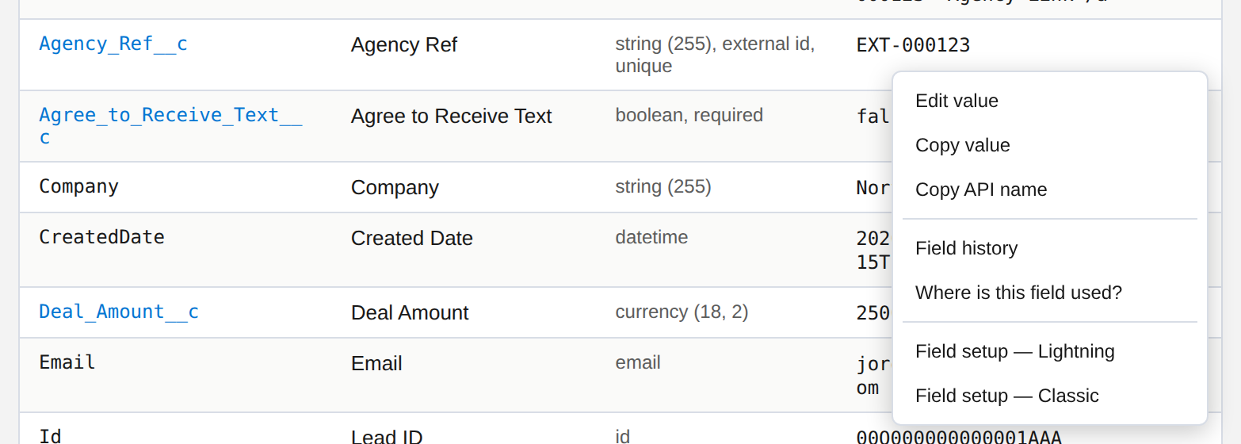
The row menu on a custom text field
Action | What it does
Edit value | Starts editing in place. Shown only for fields you are allowed to change. See 5.5.
Copy value | Copies the underlying value. A blank field copies as empty text, never the words “(Blank)”.
Copy API name | Copies the field’s API name.
Copy formula | Formula fields only. Copies the formula text.
Inspect referenced record | Lookups only. Opens the inspector on the related record, so you can walk a chain of relationships.
Field history | Shows who changed this field and when. See 5.6.
Where is this field used? | Lists the metadata that references the field. See 5.7.
Field setup — Lightning | Opens the field in Object Manager.
Field setup — Classic | Opens the field’s Classic setup page. See 5.8 for the limits.

5.5 Editing values
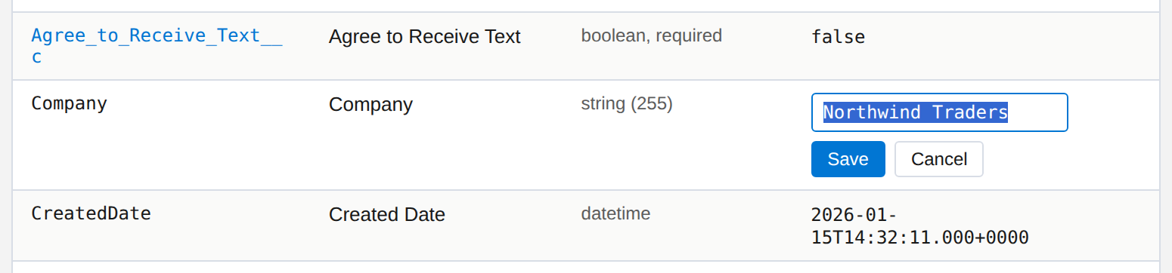
Editing a value in place
Double-click an editable value, or choose Edit value from the menu. The editor matches the field:
- Picklist: a dropdown of the active values.
- Checkbox: true or false.
- Date and date/time: a date picker.
- Number, currency, percent: a numeric box.
- Long text: a multi-line box.
- Anything else: a text box that respects the field’s maximum length.
- Enter saves and Esc cancels. Emptying the box and saving clears the field.
- If Salesforce rejects the change, for example because of a validation rule, the message appears under the box and the editor stays open with what you typed, so you can correct it.
- After a successful save the whole record is re-read, because formulas and roll-ups can change as a result. The row you edited flashes green, and the audit line updates.
Fields you cannot edit. A field only offers editing when Salesforce says you can update it and you can see it. Record IDs, formula fields, system audit dates and compound fields such as addresses are never editable here, and you cannot edit a field whose value is hidden from you.
Edits save straight to the org and there is no undo. The inspector always works on the org the record belongs to. Check the host name in the address bar before changing anything, especially in production.

5.6 Field history
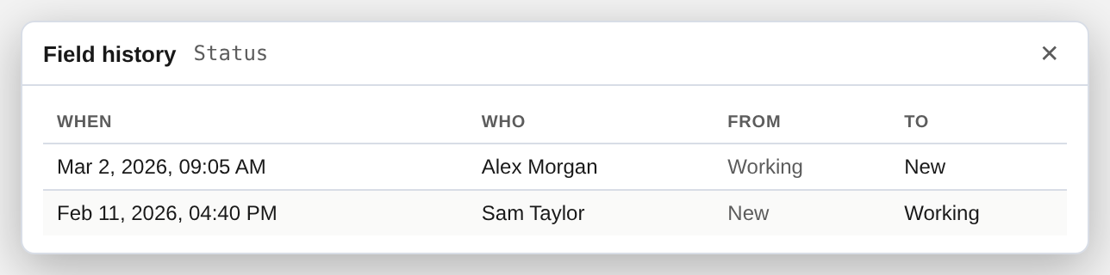
Field history for a picklist
Shows up to the 100 most recent changes to the field: When, Who, From and To. It needs field history tracking switched on for that field in Setup. If the panel says no tracked changes were found, tracking is probably off; Salesforce only records changes made after it is switched on. Objects with no history table do not support this.

5.7 Where is this field used?
Lists the Apex classes, flows, layouts and other metadata that reference a custom field. Use it before you change or delete a field.
Treat the answer as a guide, not a guarantee. This uses Salesforce’s Dependency API, which Salesforce still labels Beta and which does not cover reports. “Nothing references this field” means nothing the API knows about.

5.8 Field setup links
- Lightning goes to the field’s page in Object Manager.
- Classic goes to the field’s own page for custom fields. Standard fields have no such page in Classic, so the link opens the object’s field list instead.
- These links need the View Setup and Configuration permission to find the field. Without it, both links open the object’s field list, which is still the right neighbourhood.

5.9 If something looks wrong
Symptom | What to check
The Inspect tab is missing | You may be on a page that is not a record (home, list view, Setup). If it is a record page, refresh the tab; this is also needed after installing or updating the extension.
A field has no Edit option | You cannot update it, you cannot see it, or it is a formula, ID, audit date or compound field.
A value shows No access | Field-level security hides it from your profile. It is not blank.
Field history is empty | Tracking is probably off for that field, or the object has no history table.
Both setup links open the field list | You lack View Setup and Configuration, or the field has no Setup page of its own.
Where-used says the API is unavailable | Some orgs do not expose the Dependency API.

6. Browse and shortcuts

6.1 Pinned
Click the star beside any item (an object, flow, profile, permission set, Apex class or user) to pin it. Pinned items collect in Pinned at the top of the sidebar for one-click access. Pins are kept per org, so each org shows its own list.

6.2 Configurations
One expandable group for the org’s metadata. Each list can be filtered by name; click an item to open it in the right place in Setup, in a new tab beside your current one.
List | What you get
Objects | Standard and custom objects (managed-package objects are left out). Opens the object in Object Manager.
Flows | Every flow with its Active or Inactive status. Opens it in Flow Builder. Each row also has a Clean up versions button (below).
Profiles | All profiles. Opens the profile’s Setup page.
Permission sets | Permission sets that are not owned by a profile. Opens the Setup page.
Apex classes | Your org’s classes. Opens the class detail page.

Clean up flow versions
Flows pile up inactive versions. On any flow row, click Clean up versions to expand a small form right under it. Enter how many of the oldest inactive versions to delete (1 to 30; the default is 5) and confirm.
Safe by design. The active version is never touched. Deletion stops at the first failure, so you can investigate before trying again.

6.3 Users (active)
Lists the org’s active users, with a count. Each row has two actions:
- Login as — logs you in as that user. Admins only, and subject to your org’s Login-As policy.
- + Debug log — expands a small form to start tracing that user. Pick one of the org’s debug levels and a duration of 1, 2, 3 or 4 hours, or 1 day (24 hours is Salesforce’s limit for a trace flag). The extension creates the trace flag for you.

7. Record analysis & cleanup

7.1 Find references
Paste any record ID to find every record in the org that points to it through a lookup or master-detail field. The result shows the referencing object, the field, and the matching records; click any result to open it. Use it to understand what is attached to a record before you delete or merge it.
Both 15- and 18-character IDs work. This tool only reads.

7.2 Delete by ID
Paste a 15- or 18-character record ID. The extension identifies the object, shows the record and its related child records, and lets you choose what to delete before you confirm.
Deletion is permanent from here. Check the org name in the sidebar and read the confirmation carefully, especially when you choose to include child records.

7.3 Change owner
Moves every Lead, Account, Contact or Opportunity owned by one user to another. It is built for the common case of reassigning a departed colleague’s records, and it counts first so there are no surprises.
- From: type two or more characters and pick the user. Inactive users are searchable here, because a departed user’s records are the usual reason to open this screen.
- To: pick an active user. Salesforce will not assign records to an inactive one.
- Tick the objects to move.
- Leave Back up first ticked. Before anything is written you get a CSV of every affected record (object, record ID and current owner).
- Click Preview counts. You see a count per object and a total.
- Click Change owner for N records. The button carries the number you just counted, and a confirmation repeats it.
- Click Download backup and continue. Nothing is changed until that download has happened.
- Watch the progress bars. Records move in batches of 200, and Cancel stops the run after the batch in progress.
Good to know | Detail
Changing a selection resets the count | If you change either user or any object after previewing, the button locks until you count again. You can never transfer a different number than the one you confirmed.
Assignment rules are off by default | Salesforce runs active Lead and Account assignment rules on API updates unless told not to, which could silently re-route the records away from the user you picked. Tick Run assignment rules only if you want the rules to decide.
Converted leads are skipped | Salesforce locks converted leads, so they are left out of the count and the transfer.
10,000 records per run | Above that, the preview tells you to use Setup’s Mass Transfer Records or Data Loader.
There is no in-app undo | The backup CSV is your restore point. Load it back through Data Loader as an update to reverse the transfer. A cancelled run keeps the records it already moved.
The run continues in the background | You can close the window and reopen it to find live progress.

7.4 Data export
Builds and runs a SOQL query, then lets you download the results as a CSV file. Its job is to take away the typing: you pick an object, it writes the first line of the query for you, and as you type it suggests fields (and the fields of parent records) to add. It only reads data; it cannot change anything in your org.

Opening it
Click the Data export tab on the right edge of any Salesforce page. It sits directly below the Inspect tab, and on pages with no record it takes Inspect’s place. The query tool opens in a new browser tab beside your page, connected to that same org.
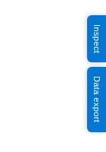
The Inspect and Data export tabs on a record page

Building a query
- Choose an object. Start typing its name or label; matches appear with their API name and a Standard or Custom tag. Press Enter, or click, to choose.
- The query starts for you, for example SELECT Id, Name FROM Opportunity LIMIT 50. The caret waits at the end of the field list, ready to type a comma and the next field.
- Type part of a field name or label. A list of matching fields opens under the word you are typing, with each field’s type. Press Tab or Enter to insert the highlighted one, the arrow keys to move, and Esc to close the list.
- Press Ctrl+Enter or click Run query.
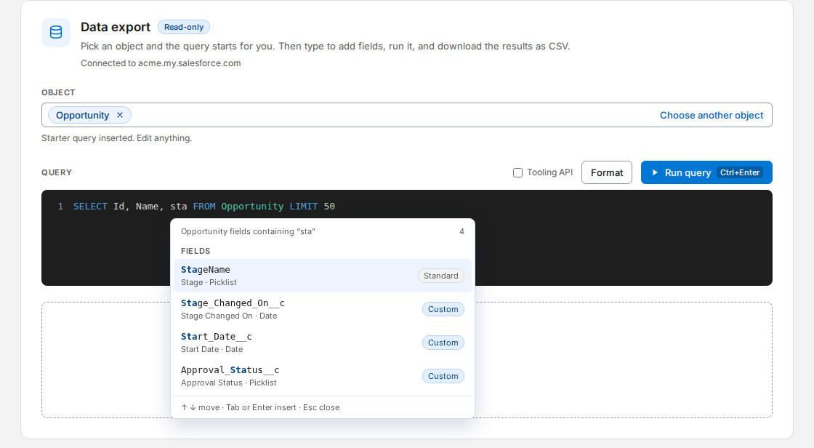
Typing “sta” after the starter query suggests matching fields
The same suggestions work in WHERE, ORDER BY and GROUP BY (where fields that cannot be filtered, sorted or grouped are left out), in subqueries, and for object names after FROM. After a comparison such as =, the next word is assumed to be a value, so no list opens; press Ctrl+Space if you want field suggestions there anyway.

Fields on parent records
A lookup field offers two different entries, and the difference matters:
- The field itself, such as AccountId. It holds only the Id.
- The parent record, shown with an arrow, such as Account ›. Choosing it inserts Account. and immediately lists the Account’s own fields, so you can pick Account.Name.
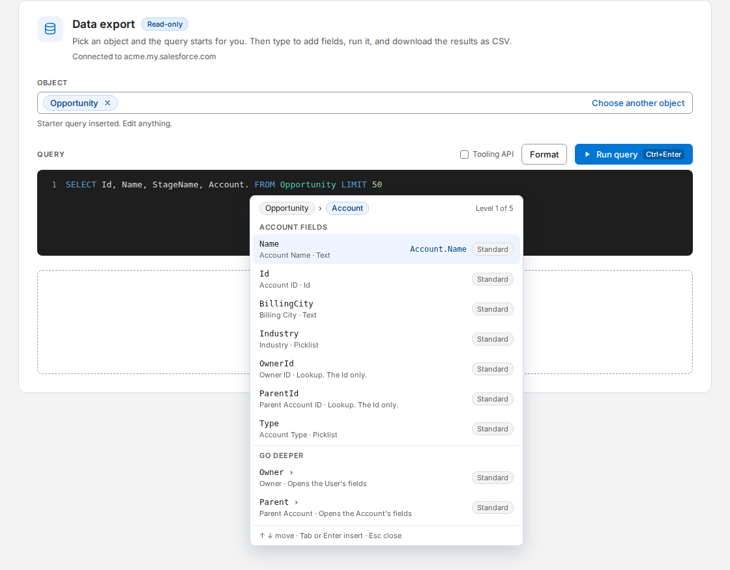
Inside the Account parent: a breadcrumb, the parent’s fields, and its own parents under Go deeper
- A breadcrumb (Opportunity › Account) and a level counter show where you are. The highlighted row previews what will be inserted, such as Account.Name.
- Go deeper lists the parent’s own parents, so you can reach Account.Owner.Email. Salesforce allows up to five levels of parents in one query, and the list stops offering more at level five.
- Custom relationships end in __r (for example Accounting_Contact__r). They are tagged Custom and work the same way.
- Backspace removes the dot and takes you back up a level.
- A relationship that can point at more than one object (an Owner can be a user or a queue) offers only the fields every possible target has, so what you pick should always run.

Format and the Tooling API
- Format puts each clause on its own line and upper-cases the keywords. Text inside quotes and inside subqueries is left exactly as you wrote it.
- Tooling API switches to the Tooling objects (ApexClass, ApexLog and so on). The object list reloads, because the two APIs have different objects.

Results and export
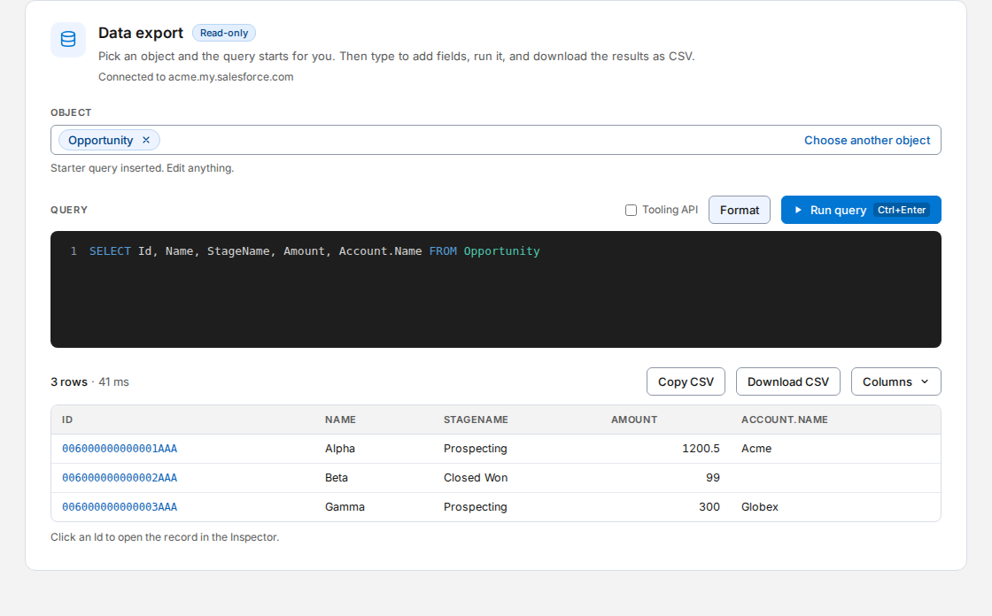
Results: columns follow the SELECT list, with parent fields as dotted columns
- Columns follow your SELECT list. Parent fields appear as Account.Name; a record with no parent leaves those cells blank, and child records from a subquery show as a count.
- Click an Id to open that record in the Record Inspector, in the tab beside this one.
- Large results load in batches. A status line shows how many have loaded, and Load more fetches the next batch.
- Columns hides or shows columns. Copy and Download use only the columns that are showing.
- Copy CSV copies the rows loaded so far. Download CSV first fetches every remaining row (up to 50,000; the button becomes Stop while it works), then saves a file named after the object and today’s date. The file opens correctly in Excel, with accents and non-English text intact.
- The page shows the first 1,000 loaded rows. The CSV always contains all of them.
Safe by design. Data export only reads. Nothing you type or download is stored by the extension, and the results travel from your org to your browser and nowhere else. If a query fails, you see Salesforce’s own error with its code and the position of the problem.

7.5 Fill form (test data)
Fills a long form with realistic fake data, so testing a New Lead form or a screen flow does not mean typing every field by hand. It is meant for QA and training sandboxes.

Opening it
When a form is on screen, such as a New Lead pop-up, a full-page New Lead form, or a screen flow, a Fill form tab appears on the right edge, below Data export. Click it to open a small panel. The panel tells you how many empty fields it found and how many of them are required.
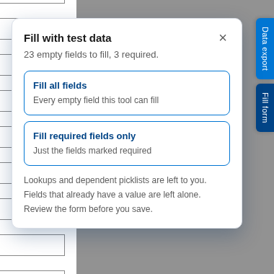
The Fill form panel, with its two options

Two options
- Fill all fields fills every empty field the tool knows how to fill.
- Fill required fields only fills just the fields the form marks as required. It is the quickest way to get a record that will save.

What it fills
- Text, long text, email, phone, website, numbers and currency. Each respects the field’s own maximum length and its minimum and maximum values.
- Picklists, checkboxes, and in flows, radio buttons and checkbox groups. For fields like Stage and Lead Status it avoids closed and converted choices.
- Dates (it opens the date picker and chooses today, so it works whatever your date format) and times.
- The data is coherent: the email is built from the name on the same form, and the website and deal name from the company. Emails use the reserved example.com domain and phone numbers use the fictional 555-0100 to 555-0199 range, so a flow or workflow that emails the record cannot reach a real person.

What it leaves to you
Lookups (such as an Account or an Owner), dependent picklists, country and state, multi-select picklists, rich text and read-only fields. Choose those yourself. After filling, the panel lists what was left, and any required field it could not fill is called out by name so a save does not surprise you.
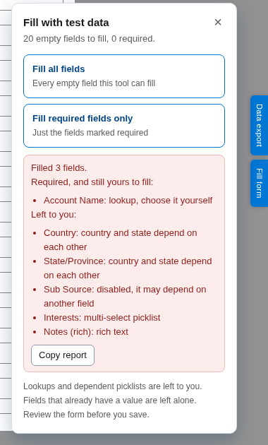
After filling required fields only: what was done, and what is still yours

Safe by design
- It never presses Save, Next or Finish. Moving on, and saving, is always your decision.
- Fields that already have a value are left alone, so defaults and anything you typed stay as they are. Press it again after you fill a lookup and it fills what is still empty.
- In a production org, or when it cannot tell, the panel warns that saving creates a real record and asks you to tick “I know. Fill it anyway.” before its buttons work.
- Everything is generated on your computer. Nothing is stored or sent anywhere.
If a field did not fill. Press Copy report in the panel. It copies a plain-text list of every field, what was done to it, and for skipped fields where they sit on the page. That is enough to see why, and to add support for it.

7.6 Compare access
Shows how two profiles or permission sets differ, with the answer first. It opens in its own tab (choose Compare access in the sidebar, then Open Compare access), because a comparison needs the width. It only reads: nothing in your org is changed.

Choosing what to compare
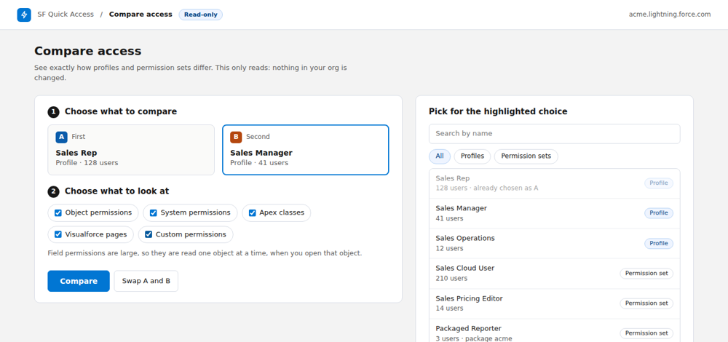
Choose two, from one list of profiles and permission sets, and choose what to look at
- Pick A, then B. Click a choice and pick from the list. The list shows how many people have each, marks ones that come from an installed package, and can be narrowed by name or to profiles or permission sets only.
- Choose what to look at. Object permissions, system permissions, Apex classes, Visualforce pages and custom permissions. Field permissions are separate (below).

The answer first, then the detail
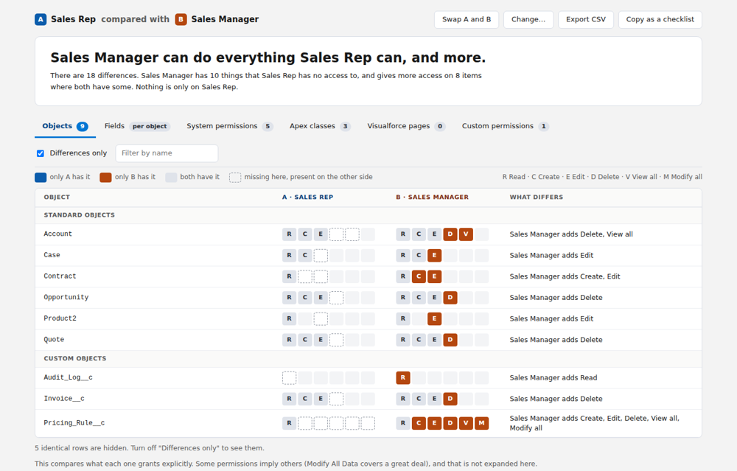
A plain-language verdict, then the matrix. Filled cells are the differences
- The verdict. For example “Sales Manager can do everything Sales Rep can, and more”, with how many differences there are and what kind. It says that only when nothing at all is on the other side. If each has something the other lacks, it says so instead.
- The matrix. One tab for each list, each showing how many differences it holds. A is blue and B is orange. A filled cell is a difference: it is the side that has the extra. A dashed cell means missing here but present on the other side.
- Differences only is on to begin with, with a count of the identical rows it is hiding. Turn it off to see everything. Filter by name narrows the table as you type.
- Letters on objects: R Read, C Create, E Edit, D Delete, V View all, M Modify all.
- Swap A and B flips the comparison without reading anything again.

Fields, one object at a time
Field permissions are the largest part by far, so they are read only for the objects you open. The Fields tab lists the objects either one has access to, says which you have read and how many fields differ in each, and reads the rest when you click. An object that is not in the list can be read by typing its API name. A field one of them cannot see at all is shown as No read, not as blank.

Taking it away
- Export CSV saves the tab you are on, with the filter you have applied. It opens cleanly in a spreadsheet.
- Copy as a checklist puts what you would change to make A match B on the clipboard, grouped by category, ready for a ticket. The tool never makes the change itself.
It compares what is granted explicitly. Some permissions imply others (Modify All Data covers a great deal), and that is not expanded. If a list could not be read, for example for a permission you lack, the page names it and the answer covers only what was read. Record-level sharing (sharing rules, the role hierarchy) is not part of a profile or permission set and is not shown.

8. Logs

8.1 Clear debug logs
Bulk-deletes ApexLog records through the Tooling API, in parallel batches. By default it removes only your own logs; untick the box to clear logs for every user in the org. Click Count logs first to see how many would be affected, then Delete all logs.

8.2 Log Analyzer
A different way to read debug logs from the Developer Console. Instead of a live view that keeps scrolling while you read, it loads a static snapshot you control. Nothing refreshes on its own; click Refresh when you want the latest.

The log list
- Columns: Size, Time, Status (Success or Error), Operation and Duration, newest first. The User column appears only when you are looking at more than one user, since otherwise every row would say the same thing.
- Time is shown compactly, for example “Oct 8, 10:20 AM”. Hover for the exact time.
- Operation is shortened if it is long; hover to read it all.
- Page size is 25, 50 or 100, with Prev and Next.

Whose logs
Choice | Shows
My logs only | Logs generated by you.
All users | Every log in the org.
One user | A search box appears. Type two or more characters and pick a person; only their logs are shown. Inactive users are included, since logs outlive the account that made them. Switching back to another choice remembers the person you picked.

Click a log for a full breakdown
- Triggers fired — name, object, events, and how many times each ran.
- Flows executed — name, times run, and whether it finished or faulted.
- DML statements — operation, object, rows and call counts.
- SOQL queries — object, query count and rows returned.
- Validation failures and callouts, when present.
- Governor limits as progress bars (SOQL queries, DML rows, CPU time, heap size and more).
- A fatal-error banner at the top if the transaction threw an unhandled exception.
Every row in every summary jumps to that exact line in the raw log below it.

The raw log
- Search with next and previous match and a match counter, plus a jump-to-line box.
- Debug only — tick it to show only your System.debug output. A debug statement that spans several lines (a JSON blob, a stack trace) is kept whole, not cut down to its first line. The toolbar shows how many lines remain, for example “142 of 3,418 lines”, and line numbers still match the downloaded file. If a jump target is not a debug line, the filter clears itself so the jump still works.
- Download raw log saves it as a .log file. Delete this log removes it from the org.
- Very large logs (over 20,000 lines) are shown as plain text so the window stays responsive; the Debug-only view often brings them back under the limit.
If Debug only finds nothing, your trace flag’s Apex level may be too low. USER_DEBUG lines need a level of DEBUG or finer.
Trigger and flow detection use pattern matching against Salesforce’s standard log format. DML, SOQL and governor-limit parsing are very reliable; trigger and flow counts are usually right but worth a quick check against the Developer Console the first time you use an org.

9. Grant access and Quick Deploy

9.1 Grant access
Bulk-grants access to Apex classes, Visualforce pages, custom fields and objects across many profiles at once. Fill in any combination of the boxes, one entry per line:
- Apex class API names and Visualforce page API names.
- Fields as Object.field, for example Account.My_Field__c, with Read (always on) and Edit. Fields that are read-only automatically skip Edit.
- Object API names with the permissions to grant: Read, Create, Edit, Delete, View All, Modify All.
- Click Resolve & find profiles. All profiles are listed, with custom profiles pre-selected.
- Adjust the selection with All, None or Custom only.
- Click Grant access and confirm.
- Each profile reports Granted, Already had access or Failed, followed by a summary line.
Under the hood it writes SetupEntityAccess (Apex and Visualforce), FieldPermissions and ObjectPermissions on each profile’s owned permission set. You need the permission to manage profiles and permission sets in the org.

9.2 Quick Deploy
Moves a few components from the org you are in to another org you are logged into, without a change set. It is built for small, self-contained changes: the couple of classes, fields or flows you just finished in a sandbox.
- Components. Type in the one search box. It finds Apex classes, triggers, LWC, Aura, Visualforce pages and components, flows and custom labels by name. A flow can be found by its API name or its label, and each result says what kind it is (screen flow, record-triggered flow and so on) and which version it is at. Click a result to add it to the list; click the cross to remove it.
- Fields are found as Object.field. Type Invoice__c.amount, or search an object name and pick it from the list to see its custom fields. (Salesforce cannot search fields by name across all objects, which is why the object comes first.)
- Target org. The extension lists every org this browser is logged into. Sandboxes come first, production is marked in red, and an expired session is shown as Expired. Click Refresh org list after logging into another org.
- Tests. This section appears only if your list contains Apex. Choose the org default, run local tests or all tests, or name specific test classes. The test search looks in the target org, because a test that exists only in your sandbox would fail the deployment.
- Click Validate only to run the full deployment check without changing anything, then Deploy.
Safeguards and limits | Detail
Validate first | Validate only changes nothing in the target org. Use it before every real deployment.
Production needs a typed confirmation | To enable Deploy for production you must type the org’s name prefix (for example acme). A confirmation dialog follows.
Tests and production | Choosing specific tests checks coverage per class, not org-wide: each class and trigger in the package needs 75% on its own. This is the usual reason a production deployment fails.
Fields, labels and flows take longer | They are retrieved from the source org first so Salesforce writes its own metadata. A mixed package is retrieved as one.
A flow deploys at its latest version | Salesforce retrieves the latest version of a flow, which is not always the active one. When they differ the result says so (for example “v5 (not active), v4 is active”), the list marks the flow as not active, and the note names which version will go.
A flow arrives as a new version | In the target it becomes a new version. In production it arrives inactive unless the org has Deploy processes and flows as active turned on, so check Setup, Flows afterwards. A reminder appears when your list includes a flow, and again after a real deployment.
What a flow uses must already exist | A flow that refers to a field, an Apex action, a subflow or a label the target does not have fails to deploy, with Salesforce’s reason. Add the missing pieces to the same package: fields and labels can be sent with it.
Flows from installed packages | Salesforce does not allow these to be retrieved, so they are not offered.
Field-level security does not travel | A deployed field is invisible to users until profile or permission-set access is granted in the target org. A banner reminds you whenever your list includes a field.
25 components per run | This is a small-deployment tool.
No dependency analysis | If a class refers to a field you did not include, the deployment fails to compile. It rolls back cleanly, and the error shows the line.
Permission needed in the target | Modify Metadata Through Metadata API Functions or Modify All Data.
Progress shows as Building, Retrieving, then Deploying. A failure lists every component error with its line number, and every test failure. A clean real deployment ends with a green banner and a short celebration. A passing validation reports success but gets no celebration, because nothing reached the org.

9.3 Recent changes
Shows which components in the org were changed lately, and who changed them, newest first. Use it to find everything you changed today before you deploy it, or to see what a colleague touched. It only reads: nothing here changes anything in your org.
It opens on your own changes from today and yesterday, which is the smallest list and the quickest to read. Choose Everyone, another person or a longer period whenever you want more.
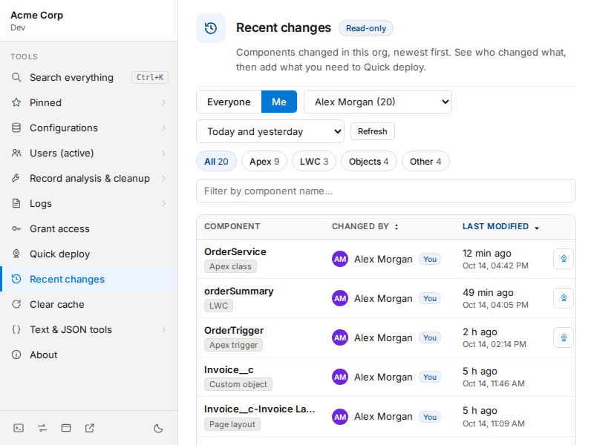
Recent changes, opened on your own changes: filters across the top, then the newest 15

Reading the table
- Component is the name and what kind of thing it is.
- Changed by is the person who last saved it. A badge marks your own changes.
- Last modified shows how long ago (“12 min ago”, “Yesterday”) and the exact time below it.
- Only 15 are shown at first. Load 15 more shows the next 15, and the footer always says how many of how many you are looking at.

Finding what you want
- Everyone / Me. It opens on Me, your own changes. Everyone shows all of them, and the Changed by list picks anyone else and shows how many changes each person made. If you have no changes in the period it says so, and offers to show everyone.
- Date range. Today and yesterday (the default, counted in calendar days from midnight yesterday), the last 7, 30 or 90 days, or all time.
- Type chips. Apex, LWC, Aura, Flows, Fields, Objects and Other, each with how many it would show. The numbers follow the person you have chosen.
- Filter by component name narrows the list as you type. If nothing matches, Clear filters puts everything back.
- Sort. Newest first is the default. Click Changed by to group by person, A to Z, with each person’s newest change first. Click it again for Z to A, and Last modified to go back or to see the oldest first.

Adding to Quick Deploy
Components Quick Deploy can move (Apex, LWC, Aura, Visualforce, flows, custom fields and labels) have a small rocket button. Press it and the component is in your Quick Deploy list, exactly as if you had searched for it. A line above the table counts what you have added and opens Quick Deploy. Custom objects, validation rules, permission sets and layouts are listed but have no button, because Quick Deploy cannot move them.
Good to know | Detail
What it covers | Apex classes and triggers, Visualforce pages and components, LWC, Aura, custom labels, flows, custom objects, custom fields, validation rules, page layouts and permission sets.
Components from installed packages | Not listed.
“Changed by” means the last person to save | Not necessarily who created it. A component that arrived by deployment shows the person who deployed it.
A flow shows once | A flow is saved as numbered versions. It appears once, at the time of its newest version, by whoever saved that version.
Your list appears first | Most kinds of component are read quickly because Salesforce can filter them by date. Custom fields and layouts cannot be filtered that way, so they take longer however short the period. They are read separately: the list appears without them, a line says it is still reading them, and they join the list when they arrive.
Then it is kept for two minutes | Filtering, sorting and Load 15 more are instant. Refresh reads everything again.
Newest 500 of each kind, 1,500 in all | If a kind of component has more than 500 changes in the period, or the period has more than 1,500, a note says older ones are not listed. Choose a shorter period to see them.
A kind it could not read | If one kind fails (a permission you lack, say), a note names it and why, and everything else is still shown.
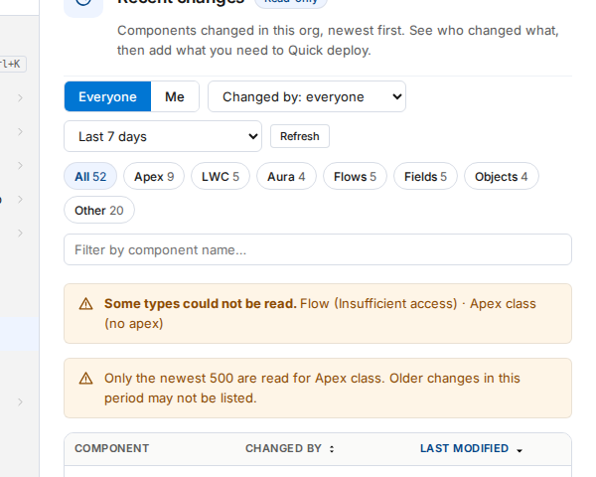
A note names a kind of component that could not be read, and the rest is shown

10. Utilities

10.1 Clear cache
Makes a Salesforce tab reload as if you had pressed Ctrl+Shift+R, every time, so you never see a stale Visualforce page, static resource or Lightning bundle after a deployment. Your login is untouched and cookies are never cleared.
- The switch at the top turns it on or off for the tab you opened the extension over. A tab’s own choice lasts until you close the tab.
- Reset to default hands the tab back to the default below.
- Clear this org’s cache now clears once without turning anything on. Clear and reload tab also reloads the page, bypassing the cache.

Defaults for every tab
Further down, Off by default can be switched on so every Salesforce tab starts with cache clearing enabled. A tab’s own switch always wins. What gets cleared is configurable:
Option | Default | Notes
Bypass the HTTP cache | On | The part that makes a refresh behave like a hard reload. Turning it off leaves only the weaker storage purge.
Cache Storage | On | Service-worker caches for the org. Cheap to clear every time.
IndexedDB (slow) | Off | Where Lightning keeps its component cache. Clearing it works but makes Lightning rebuild from scratch every refresh. Turn it on only while chasing a stale component.
localStorage (slow) | Off | Cached app state. Same trade-off.

10.2 JSON beautifier
One text box and five buttons. Paste JSON and it is formatted automatically. After that, Beautify and Minify reformat the same text in place, using two-space indentation.
- Validate checks the JSON and, if something is wrong, reports the exact line and column with the offending line and a caret under the problem. The cursor jumps to it.
- Copy to Clipboard copies the current text. Clear empties the box.
- Ctrl+Enter beautifies.
- A failed Beautify, Minify or paste never changes your text: you get the error and keep what you had.

10.3 String converter
Paste a list of items, one per line or comma-separated, and convert it to another shape. Useful for turning a column of IDs into a SOQL IN clause.
- Text processing: trim whitespace, remove duplicates, remove empty lines, sort alphabetically.
- Case conversion: keep as-is, UPPERCASE, lowercase, Title Case.
- Convert to: CSV with single or double quotes, SQL IN clause, JS array, Python list, one per line, comma plus space, pipe, tab, Markdown list, HTML list, XML elements.
- Quick templates for Salesforce IDs, email lists, URLs and JSON arrays.
- Copy to Clipboard, Download as TXT or Clear Output, with live statistics.

10.4 About
Shows the extension version and a short description.

11. Safety at a glance
Which tools can change something, and what stands in the way of a mistake.
Tool | Can change | Safeguards
Record Inspector | A field value, when you edit | Only editable fields offer it. Errors keep the editor open. No undo and it saves immediately.
Find references | Nothing | Read-only.
Delete by ID | Deletes records | Choose what to delete, then confirm.
Change owner | Record owners | Preview count, count-locked button, backup CSV before any write, assignment rules off by default, cancel.
Clear debug logs | Deletes logs | Own logs only by default; Count logs first.
Log Analyzer | Can delete one log you open | A separate, labelled button.
Grant access | Profile and permission-set access | Choose the profiles; per-profile results show what happened.
Quick Deploy | Metadata in another org | Validate only first; production needs a typed confirmation; per-class coverage warning; rolls back on error.
Fill form | Values in the form on screen (not saved) | Never presses Save, Next or Finish; leaves existing values alone; warns in production before its buttons work.
Recent changes | Nothing (it only reads) | Lists names, dates and people. The one thing a row can do is add a component to your Quick Deploy list.
Compare access | Nothing in Salesforce | It reads permission settings only. "Copy as a checklist" produces text; it changes nothing.
Data export | Nothing in Salesforce | It only runs read-only queries. Downloads go to your computer; nothing is stored by the extension.
Flow version cleanup | Deletes old inactive flow versions | Never the active version; stops on first failure; 1 to 30 at a time.
Clear cache, JSON, String converter | Nothing in Salesforce | They work on your browser or on text you paste.

12. Usage tips
- Always glance at the org block (top left of the sidebar) before a tool that changes something. Production is red. If you work in several orgs, use a separate window for each.
- Record IDs: both 15-character and 18-character IDs work everywhere an ID is expected.
- Manual refresh by design: Clear debug logs and the Log Analyzer never refresh a list you are reading. Click Refresh or Count when you want current data.
- Validate before you deploy, and validate against the org you are about to deploy to.
- Copy as TSV in the Inspector pastes cleanly into a spreadsheet, which is handy for comparing two records.
- A short celebration plays when Change owner, Grant access or a real deployment finishes cleanly. It is skipped if anything failed, and respects your system’s reduced-motion setting.

13. Troubleshooting
Problem | What to try
The sidebar is empty or says there is no session | Confirm you are on a Salesforce tab (*.salesforce.com, *.force.com, *.my.salesforce.com and so on). Refresh the tab so the session is detected. If you just installed or updated, reload the extension in chrome://extensions.
The extension will not load, or a feature is dead | Open chrome://extensions, find the extension and click Errors. Reload it, and reload from the SF Quick Access folder, not its parent.
A sidebar group will not expand | Click the row itself or its chevron on the right.
The org shows as expired in Quick Deploy | That org’s session has ended. Log in to it in another tab and click Refresh org list.
Quick Deploy says you cannot deploy to that org | You need Modify Metadata Through Metadata API Functions or Modify All Data in the target org.
A production deployment fails on coverage | With specific tests, each class needs 75% on its own. Include its test class, or run local tests.
Log Analyzer counts look off for one log | Pattern matching is tuned to the standard log format; an unusual org-specific line could need an adjustment. The DML, SOQL and governor-limit sections are unaffected.
Debug only finds nothing | The trace flag’s Apex level may be too low to record USER_DEBUG lines.
Compare access says a list was “not read” | The banner names it and gives Salesforce’s reason, usually a permission you lack for that kind of setting. The rest is still compared, and the answer covers only what was read.
Compare access shows fewer permissions than I expected | It compares what each one grants explicitly. A permission implied by another (for example by Modify All Data) is not expanded.
A “search fields” result is empty in Search everything | See section 4. Use the Record Inspector instead.
The Inspect tab is missing | See section 5.9.
Data export says it cannot find a Salesforce session | Log in to that org in another tab, then reload the Data export page.
The tabs turned into one that says Refresh page | The extension was updated or reloaded while this page was open, so the page is still running the old copy. Press it, or refresh the page, to load the new one.
Two sets of tabs, or tabs that behave oddly | If both the Chrome Web Store version and an unpacked copy are installed, they put their tabs on the same page. Turn one off at chrome://extensions while you test the other.
The Fill form tab does not appear | It shows only when a form with at least two labelled boxes to type in is on screen (a New Lead pop-up or page, a flow screen), and appears within a second of the form opening. It does not show on list views or record pages, which have no form. If a form is open and the tab still does not show, press Alt+Shift+F: the panel opens anyway with a report of what is on the page, and Copy report gives you something to send so that page can be supported.
Recent changes says some types could not be read | The note names each one and why. Usually it is a permission your user lacks for that kind of component. Everything else is still listed. Press Refresh once the permission is sorted.
A change shows “Unknown user” | The person who last saved it could not be looked up, for example because that user was deleted or you cannot see them. The component and time are still right.
A flow deployed but is not active in the target | That is expected in production unless the org has Deploy processes and flows as active turned on. Open Setup, Flows and activate the new version. Check that it is the version you meant: Quick Deploy sends the latest version of a flow, which may be a newer draft than the active one.
Fill form skipped a field | Lookups, dependent picklists, country and state, multi-select picklists, rich text and read-only fields are left to you on purpose. For anything else, use Copy report in the panel to see why.
No suggestions appear in Data export | Choose an object first. After a comparison such as = the next word is treated as a value; press Ctrl+Space to ask for fields anyway.

14. Known limitations
Worth knowing before you rely on a result.
- Field search in Search everything depends on a Salesforce object that some orgs reject. When it is unavailable the group is simply empty, with no error shown.
- Where is this field used? uses Salesforce’s Beta Dependency API and does not cover reports.
- Quick Deploy cannot work out dependencies, handles at most 25 components, and does not carry field-level security.
- Fill form cannot know your validation rules or duplicate rules, so a form may still refuse to save. Fields that only appear after another field is filled are not seen until you press it again.
- Data export suggests fields from what your org’s metadata reports, so a field hidden from you by field-level security is never offered. It shows the first 1,000 loaded rows on screen, and a CSV download stops at 50,000 rows.
- Change owner stops at 10,000 records per run and cannot be undone from inside the extension.
- Record Inspector edits have no undo, and a handful of field types (compound fields, formulas, IDs, system dates) cannot be edited.
- Field setup in Classic exists only for custom fields.
- The Record Inspector page keeps its own simpler styling and does not yet share the main window’s new design.

15. Shortcuts
Shortcut | Where and what
Ctrl+K (Cmd+K on Mac) | Main window: open Search everything.
Ctrl+Enter (Cmd+Enter) | JSON beautifier: beautify. Data export: run the query.
Ctrl+Space | Data export: show suggestions on request.
Alt+Shift+F | Fill form: open the panel, and a report of the page, even when the tab does not show.
Tab or Enter | Data export: insert the highlighted suggestion.
Ctrl+F (Cmd+F) | Record Inspector: jump to the filter box.
Esc | Record Inspector: close the open menu or panel, then clear the filter. In the editor: cancel.
Enter | Record Inspector editor: save (except in a long-text box, where it adds a line).
Double-click a value | Record Inspector: edit it.

16. For maintainers
The package includes two developer folders. Neither is needed to use the extension.
- tests — plain Node scripts with no dependencies. Run node tests/test-packaging.js after any change to the manifest, markup or stylesheet. It walks the service worker’s imports, checks every referenced file exists, and verifies theme parity and the icon sprite. test-record-inspector.js covers the Inspector and test-log-debug-filter.js the Log Analyzer.
- tools/check-render.py — loads the real popup in a headless browser (Playwright and Chromium) and measures what is drawn: icons as outlines, aligned columns, readable contrast in both themes, 32-pixel controls. Run it before shipping any change to the popup’s HTML, JavaScript or CSS. tools/review-shots.py takes screenshots of every panel for a human to review.
Tests for Quick Deploy, Change Owner, the metadata retrieve and tab resolution were lost in an earlier environment reset and have not been rebuilt. Quick Deploy writes to production, so that suite is the first one to restore.

